EXHIBIT "M"

EXHIBIT M-PAGE 1 OF 4

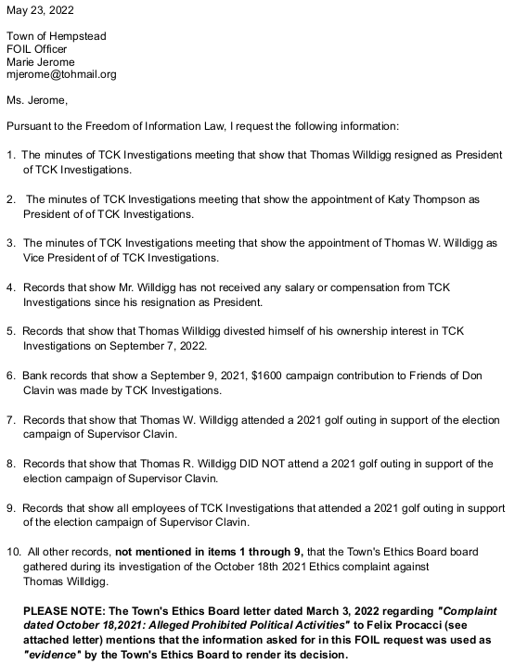

EXHIBIT M-PAGE 2 OF 4


EXHIBIT M-PAGE 3 OF 4

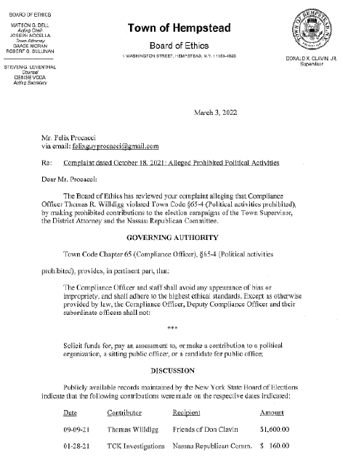
EXHIBIT M-PAGE 4 OF 4

